Host a Healthy Products House Party

It’s NOT okay to be contaminated without consent!
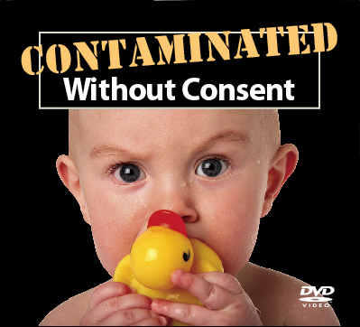
Everyone is at risk from exposure to toxic products, even products that could be safe. Share information with your family, friends, and community about why the INVISIBLE issue of toxic homes must be a priority. Contaminated Without Consent brings experts into your living room. The video stars real people and green chemistry experts!

YOU SHOULDN’T HAVE TO BE A SCIENTIST TO KNOW HOW TO BUY SHAMPOO, TOYS, OR ANY CONSUMER PRODUCTS!

We’ll send you the 16 minute video for free. Please utilize the DVD to educate people and protect public health. Call or e-mail us to get your copy!
stephdh@earthlink.net

Preview the DVD online at: http://contaminatedwithoutconsent.org
Show Contaminated without Consent EVERYWHERE!

• Home
• Neighborhood meeting
• Local school – science class
• PTA meetings
• Place of worship
• Community events
• Public Library
• Other ideas?

Turn Concern into Action
Our chemical regulatory system needs reform. Once your family, friends, and community know more about this issue they will want to take action. Help mobilize people to pass laws to protect health. Legislators on federal, state, and local levels working on this issue will appreciate your support!

Start a list of merchants in your area selling less toxic toys, personal products, home furnishings and other consumer products. Vote with your dollars! Support a less toxic economy!

