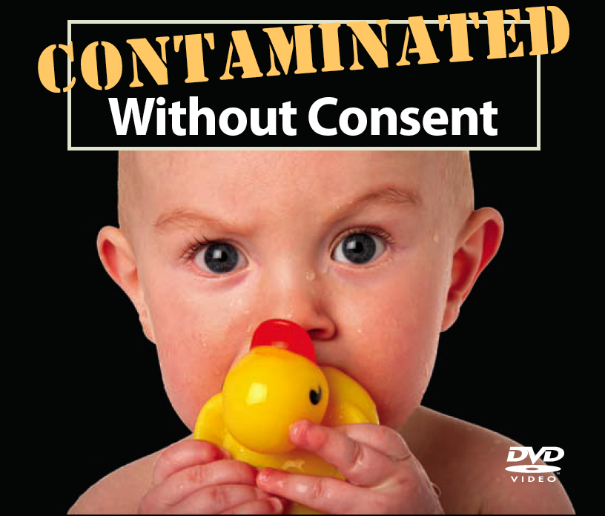

VIDEO SCREENING

Contaminated Without Consent is a new 16 minute video on toxics in everyday consumer products — contaminating our homes, workplaces, and our bodies. Learn what you can do to protect yourself and your family.

LOCATION DATE:

